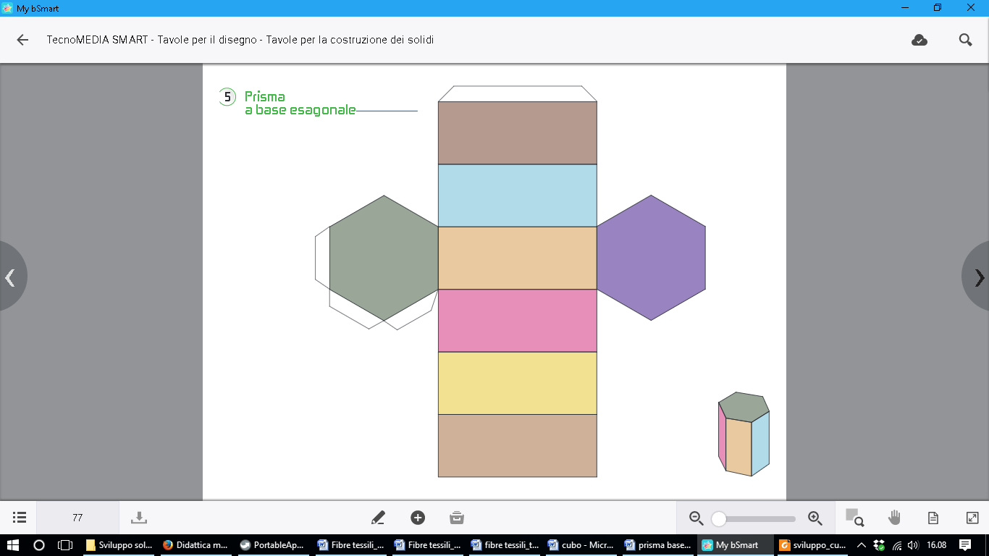

AB = 3 cm

AG = 8 cm

H

G

F

E

D

C

B

A